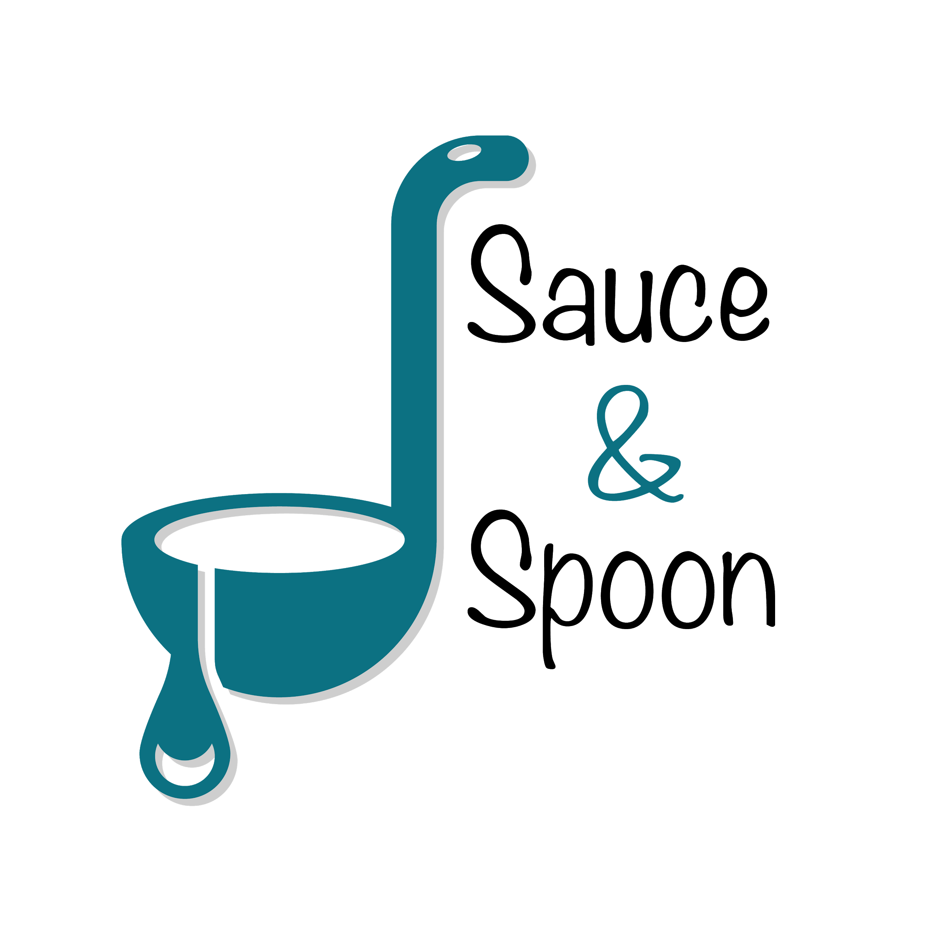

Project Charter: [Menu Tablets]

DATE: [2021/05/09]

|  |
| --- |
| **Project Summary** |
| Launch a pilot rollout of tabletop menu tablets at two of our restaurant locations, Sauce & Spoon North and Sauce & Spoon Downtown bars. That way, guests can place their orders on the tablets as soon as they arrive at the restaurant. |

|  |
| --- |
| **Project Goals** |
| * digitizing the ordering process * speed up service and other various processes * turn tables more quickly and serve more guests * offer us clear data points so that we can track metrics that help ensure the restaurant’s success * growing digital presence in the restaurant industry, allowing us to provide customers with a familiar digital experience * increase our product mix (upsell with appetizers or promote certain entrees) * decrease our average table turn time by about 30 minutes * increasing our average daily guest counts by 10% * decreasing wait time for guests * open up two part time line cook roles * adjust appetizer goal by location * SMART: Increase appetizer by 15% sales by June * SMART: Increase average check to at least $75 after implementing the project in first few weeks |

|  |
| --- |
| **Deliverables** |
| * Rolling out tabletop menu tablets where guests can place their orders * suggest any menu item as an add-on * display a coupon for that item * payment though tablets * modifies menu list and communicate directly with kitchen * integrate with existing POS and host software * Clear data points to track metrics * A plan to train the staff on the new system * Increase appetizer sales by 15% * Average check at least $75 * Two new part time line cook * Implement by June |

|  |
| --- |
| **Scope and Exclusion** |
| **In-Scope:**   * Implement menu tablet * Increase appetizer sales * add menu suggestions * offer coupon * training to staffs   **Out-of-Scope:**   * Change policy – we won’t have to replace meals when a guest claims we got their meal wrong because the tablet will show that we didn’t |

|  |
| --- |
| **Benefits & Costs** |
| **Benefits:**   * Guest will order their food from tablet and reduce time * Increase restaurant appetizer sales * Ensure customer satisfaction * Decrease average table turn time   **Costs:**   * Training materials & Fees - $10,000 * Hardware and software implementation across locations - $30,000 * Maintenance - $5,000 * Updated website and menu design fee - $5,000 * Customization fee - $550 * Total - $40,550 |

|  |
| --- |
| **Appendix:** |
| * Different appetizer goal for different locations – average of 15% * Adjust payrolls from front to kitchen – add part time line cook * Increase employee satisfaction – need more metrics to discuss * Change policy – need further discussion on this topic |